PRESS RELEASE
COMMUNICATIONS AND MEDIA TEAM OF THE 43RD ASEAN SUMMIT 2023
No.78/SP/TKM-ASEAN2023/ENG/9/2023

Four Conditions for ASEAN to Become Epicenter of Growth
Jakarta, 5 September 2023 – The ASEAN region can become the epicenter of growth if it is able to fulfill four conditions, namely hard work, unity, courage, and agility.
For every country in the Southeast Asia region to effectively anticipate every future challenge, they must satisfy these four essential capitals.
“ASEAN's direction is clear, to become the epicenter of growth. ASEAN has a lot of capital to achieve it," said President Joko “Jokowi” Widodo during the Plenary session of the 43rd ASEAN Summit at the Jakarta Convention Center (JCC), Jakarta, on Tuesday, 5 September 2023.
The four main capitals, continued the President, can be synergized with long-term tactical strategies that are in line with community aspirations in the future and can be included in discussions on ASEAN Concord IV.
"Let us together realize equal and mutually beneficial cooperation to sail together towards the Epicentrum of Growth," said the Head of State.
The commencement of the 43rd ASEAN Summit ceremony began at approximately 10 a.m. Western Indonesian Time (WIB). The event commenced with the rendition of the ASEAN anthem “The ASEAN Way,” performed by the Gitabumi Voices choir, accompanied by the Purwacaraka Orchestra.
Next, the Aemove Dancer presented a modern dance performance choreographed by Reza Muhammad and Evi Lesar. Following a series of performances by a number of artists, President Jokowi delivered a speech for about five minutes, in which he underlined the need for ASEAN countries to promote equality.
In the last session, the ASEAN Prize 2022 was awarded to Haji Muhammad Iqbal Fakhiri bin Haji Damit in the Youth Advocate and Community Leader category, and the ASEAN Prize 2023 was presented to Nguyen Thi Thuyet Minh in the Advocate of Women Socio-Economic Empowerment category.
The Prizes were awarded symbolically by President Jokowi in the presence of ASEAN Secretary-General Kao Kim Hourn.
Furthermore, there was a soft launching of the ASEAN Coordinating Center for Transboundary of Haze Pollution Control. During the event, President Jokowi pressed a button marking the commencement of the activity. (John/TR).
***

For more information, please contact:
Director For Information and Media Services of the Ministry of Foreign Affairs – Hartyo Harkomoyo (0811831899).
Get more information at http://asean2023.id, https://infopublik.id/kategori/asean-2023, and https://indonesia.go.id/kategori/ragam-asean-2023

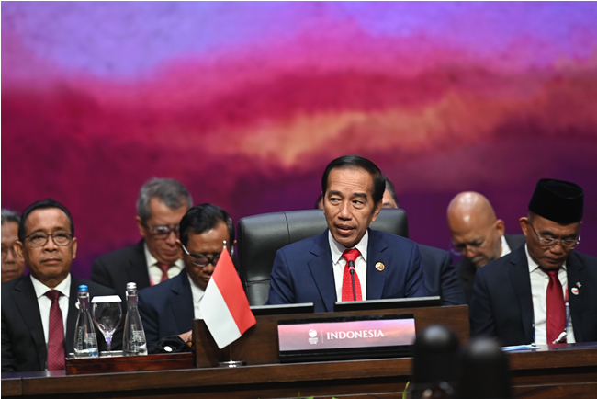
Indonesian President Joko Widodo expresses his views during the Plenary Session of the 43rd ASEAN Summit at the Jakarta Convention Center, Jakarta, Tuesday, 5 September 2023. Media Center of 2023 ASEAN Summit/M Agung Rajasa/pras

